Hanging Sleeve Instructions

(adapted from www.quiltweek.com)

Step-by-steps instructions for adding a hanging sleeve:
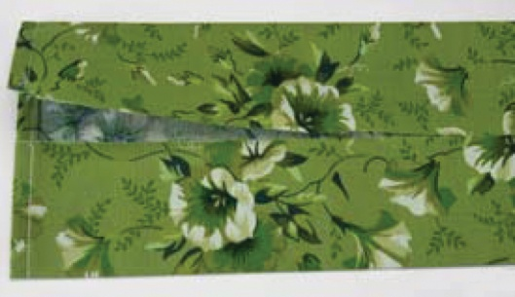
1. Cut the sleeve 8½” wide x the exact width of your quilt.
Fold the ends in twice (¼” and ¼” again) to finish each end of the sleeve. Stitch using a scant ¼” seam allowance.
Press the long sides of the sleeve so they meet in the center. It helps to fold the sleeve in half lengthwise first and press to give you a center crease.
When you press the sides to the center, you’ll press those creases out – they just give an easy guide without measuring or marking.

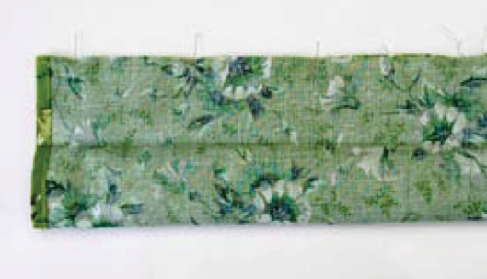
2. Fold right sides together and stitch ¼” seam on the long edge of the sleeve. Turn the sleeve right-side out.

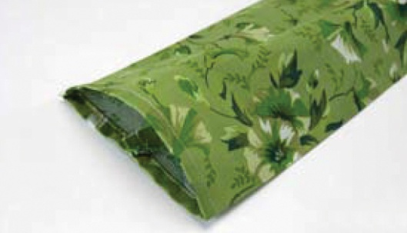
3. You may need to repress the fold lines – you’ll need those for attaching the sleeve to your quilt.
This is the step that provides the give needed in the sleeve.

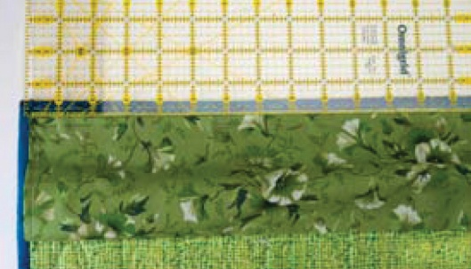
4. Center the sleeve across the width of your quilt. The edge of the sleeve should lie just inside your binding on each side of the quilt.
Using the fold, pin your sleeve in place ½” to ¾” from the top outside edge on the back of the quilt. This spacing is needed so the sleeve will not show after it is hung.
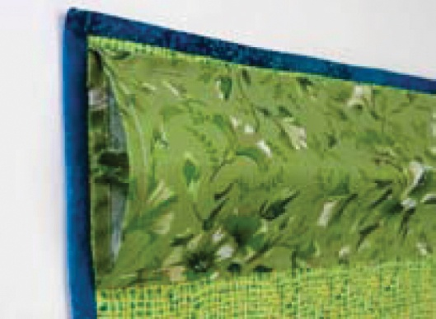
5. Pin the top of the sleeve along the fold and blindstitch in place.
Use the opposite fold line to pin the bottom edge of the sleeve in place; blindstitch to the quilt. The sleeve will fit flat against the quilt from fold line to fold line; the rest of the sleeve will cup out giving enough play in the fabric to fit into the hanging rod
.

